**Advantages of Databases Integration with Python:**

Integrating databases with Python allows easy storage and retrieval of data. Python provides libraries that simplify database operations, enabling efficient data management. This integration enables developers to build robust applications with persistent data storage, data analysis capabilities, and seamless data exchange between Python and databases.

**Supported Databases in Python:**

Python supports various databases, including popular ones like MySQL, PostgreSQL, SQLite, and Oracle. These databases have dedicated Python libraries that provide APIs to interact with them. Developers can choose the database that best suits their project requirements and use Python's database libraries to work with them.

**MySQL Database Integration Prerequisites:**

To integrate Python with MySQL, you need to have the MySQL Connector/Python library installed. This library allows Python to communicate with the MySQL database. It can be installed using pip, the Python package installer, and requires the MySQL server to be running and accessible.

**Creating MySQL Database Connection:**

To establish a connection to a MySQL database in Python, you need to provide the necessary connection details such as host, username, password, and database name. Using the MySQL Connector/Python library, you can create a connection object that represents the connection to the database.

**Executing Queries:**

Once the connection is established, you can create a cursor object to execute SQL queries on the MySQL database. The cursor provides methods like `execute()` to execute SQL statements and retrieve the results. You can use these methods to perform various database operations such as selecting, inserting, updating, and deleting data.

**Closing Database Connection:**

After performing the required database operations, it is essential to close the database connection using the `close()` method. Closing the connection releases resources and ensures that the connection is properly terminated. Failing to close the connection may lead to resource leaks and can impact the performance of the application and the database server.

**Why Closing Database Connection is Important?**

Closing the database connection is important as it frees up system resources and ensures proper termination of the connection. Open connections consume memory and other system resources and keeping them open unnecessarily can lead to resource exhaustion. Closing the connection also ensures that any pending transactions are committed or rolled back, avoiding potential data inconsistencies.

**CRUD Operations**

**1. Create:**

The Create operation involves adding new data or records to a database. It typically involves inserting a new row into a table. For example, when creating a user account, you would insert the user's information (such as username, email, and password) into the database, creating a new record.

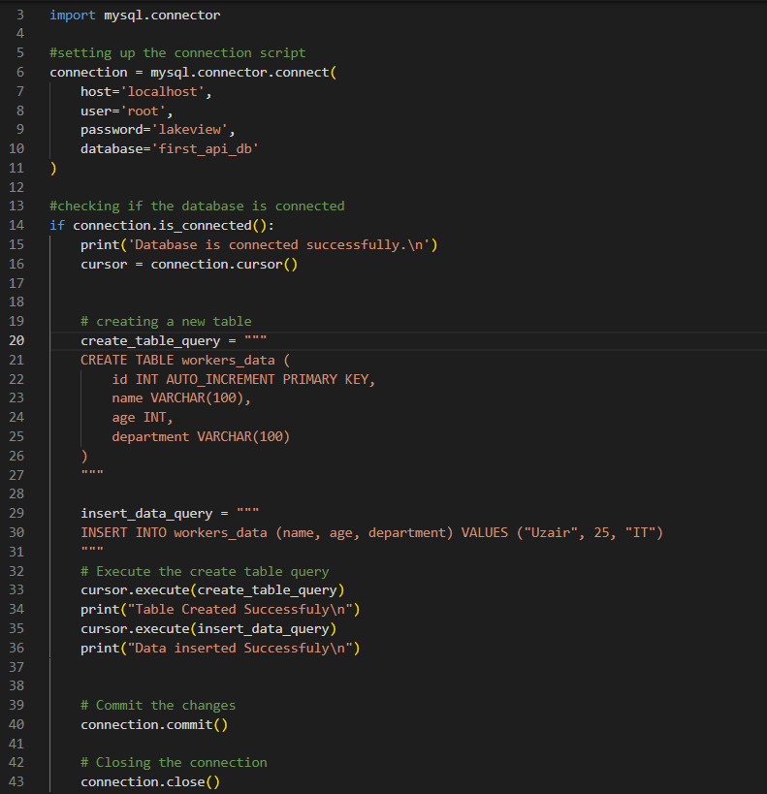

**2. Read:**

The Read operation involves retrieving or reading data from a database. It allows you to fetch and view existing data stored in the database. For instance, you might use the Read operation to retrieve a user's profile information or fetch a list of products from a product catalog.

**3. Update:**

The Update operation allows you to modify or update existing data in the database. It is used when you need to change the values of specific fields within a record. For example, if a user updates their email address or if you need to change the status of an order from "pending" to "completed," you would use the Update operation to make those changes in the database.

**4. Delete:**

The Delete operation is used to remove data from the database. It allows you to delete specific records or entire rows from a table. For instance, if a user decides to delete their account, you will use the Delete operation to remove their user record from the database.

